Let me guide you through this! The interaction of scribe and later readers on the manuscript pages of AM 243 bα fol.
Abstract: The oldest and most complete manuscript of the Old Norwegian Konungs skuggsjá, AM 243 bα fol., offers a treasure trove of knowledge on various subjects. This comprehensive encyclopaedic and didactic work can be hard to navigate through, and thus AM 243 bα fol. bears witness to the intense interaction of later readers with this manuscript to find their way through natural wonders, mirabilia, and lectures on the court.

The King’s mirror
Konungs skuggsjá or “The King’s Mirror” (in Latin Speculum regale) is an extraordinary historical and encyclopaedic text that is considered one of the main works of Norwegian mediaeval literature. The text addresses the most important issues of mediaeval society, such as the tasks of a merchant, the duties of a king and his court, and the role of the church and clergy.
These educational topics are presented to the reader through a knowledge exchange between a father and a son in the form of a dialogue. The contrived conversational format is not uncommon for this kind of literary work, as it follows the well-established frame for instructional texts in the Middle Ages (known as ‘Lehrdialog’; cf. e.g. Elucidarius, Hortus deliciarum, Le Livre de Sidrac). However, the text of Konungs skuggsjá does not only adhere to this tradition but goes beyond it by incorporating elaborate recursiveness in its questions and answers.
The text of Konungs skuggsjá has been the object of numerous literary and historical research with efforts to date its composition in relation to other manuscript texts and identifying potential sources accessible to its author. Influences from other educational works and Bible translations like the Vulgate have been pointed out, however, Konungs skuggsjá has been said to be “an original work in the vernacular”.

The Arnamagnæan manuscript
Konungs skuggsjá survives in around 60 manuscripts in both Old Norwegian and Old Icelandic, many of which are fragmentary. The oldest manuscripts of Konungs skuggsjá were written in Norway in the latter half of the 13th century, while the youngest are from Iceland from as late as 1800. Two of the oldest Norwegian manuscripts are housed in the Arnamagnæan Collection in Copenhange: AM 243 bα fol. from ca. 1270 and AM 1056 IX 4to from ca. 1300.
The manuscript of AM 243 bα fol. is the main manuscript in Old Norwegian and codex optimus of Konungs skuggsjá. Although no manuscript has been fully preserved and thus even this main manuscript shows several lacunae, it nevertheless contains approximately 80% of the text. As such, it presents the most comprehensive manuscript of this text.
Box start
The manuscript of AM 243 bα fol.: AM 243 bα fol. comprises 68 parchment leaves, each featuring two columns, measuring approximately 278 x 213 mm. There are 30 lines per leaf, with only a few exceptions of 29 or 31 lines. The manuscript must have originally comprised 86 leaves, organized into 11 quires (see Figure 1). Today, however, the manuscript is missing the first three leaves of quire 1, the entirety of quire 2, the first leaf of quire 5, the last leaf of quire 10, and all leaves of quire 11 except for the third.
Box end
However, because of the lacunae, the main manuscript is missing the prologue, prompting debate amongst scholars as to whether it was in the manuscript at all. The text starts with the words Goðan dag hærra minn (‘Good day, my lord’) on the second half of the first page. The lacunae in AM 243 bα fol. result in the text missing the final part of the chapter on the tides and the course of the sun, the initial parts of the following chapter on the natural wonders of Ireland, all chapters about Iceland (4 chapters on whales and the kraken, wonders, volcanic fires and mineral springs), the final part of the chapter on how to approach the king, the final part of the chapter on the judgements of Solomon and the initial part of the chapter on promises (Joab).
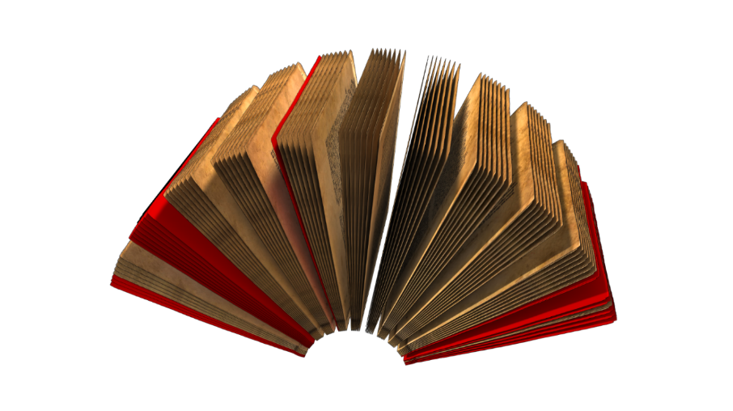
Fig. 1: Lacunas of AM 243 bα fol. (ill. by Frank Agledal).

Comments, analysis, and guidance
Throughout the centuries, AM 243 bα fol. Has been passed through many owners, with some leaving their marks on its pages. Notes, comments, and accentuations in the margins, as well as in interlinear positions on the manuscript page, bear witness to a consistent consultation of the text and active reading, reflecting a rich history of engagement with the manuscript. Árni Magnússon played a significant role among the manuscript’s holders in adding valuable information, documenting its original state, and providing details on the mentioned lacunae through six AM-slips attached to the beginning and the end of the manuscript.
The margins of AM 243 bα fol. reveal fascinating additions made by later readers, primarily in the 14th and 15th centuries. Some of these marginalia serve as helpful navigational aids, guiding readers through the text and allowing them to quickly transition from one topic to the next. Several marginal structuring devices show repetitions of names or specific keywords taken from the main text as shown in fig. 2. Others offer brief summaries of specific passages, akin to titles, as in fig. 3.
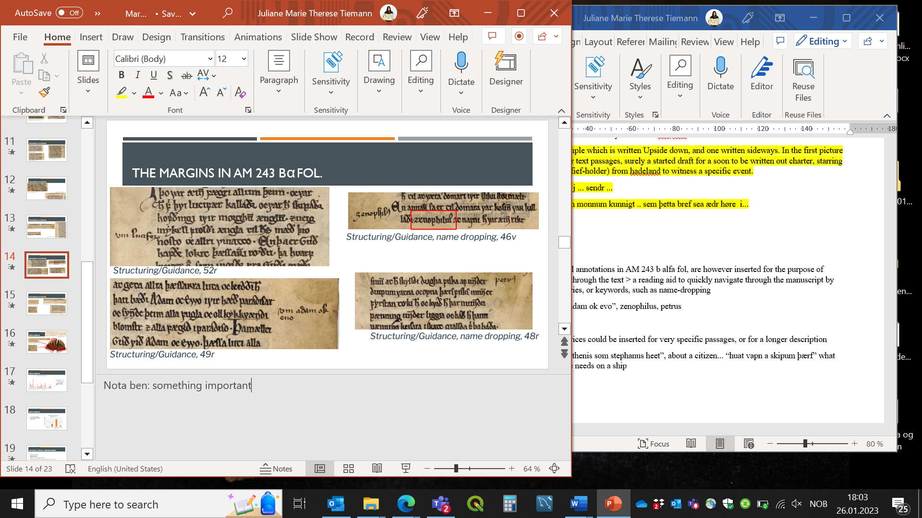
Fig. 2: Repetition of the name ‘Zenophilus’ in the margins, f. 46v.
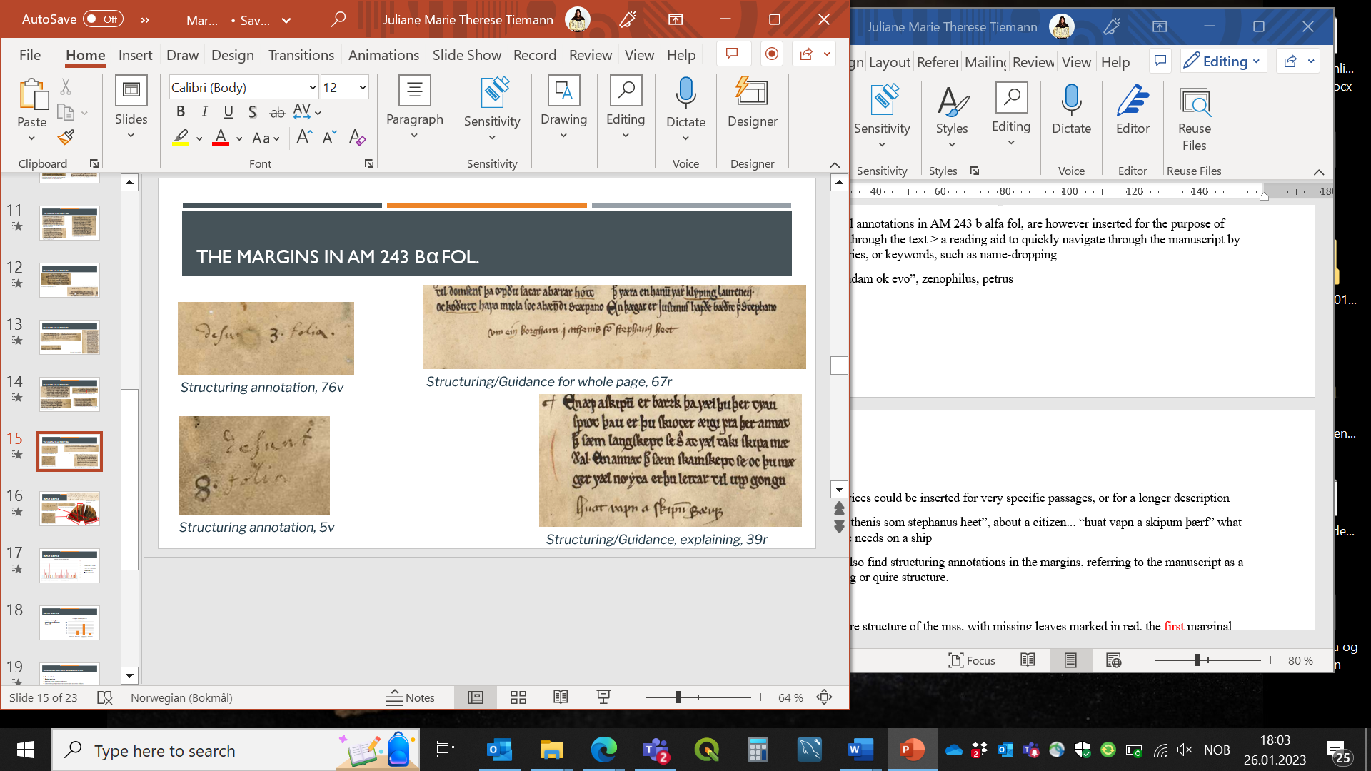
Fig. 3: Short summary reading Huat vapn a skipu(m) þærf ‘what kind of weapons one needs on a ship’, f. 39r.
And there is even more to these guiding aids! Some of the comments and notes form a kind of collaboration between the author and later reader throughout time. These combined efforts to make the manuscript text more easily approachable operate on three distinct yet interconnected levels – textual, graphical, and notational. The structuring of information both on a purely textual but also on a visual level has gone through several editorial processes to complete a guiding process for readers. If we for example delve into the Norwegian periphery, specifically the chapter on Ireland, we encounter the introduction of three lakes, each connected to miraculous happenings.
The description of the wonders associated with these lakes follows a rhythmic pattern, employing a repeating formula that reads (in variants): Ða er þar ænn vatn æitt miket … (6v, col.a:27, ‘Then there is a large lake ...’). This repetition (marked by underlining in fig. 4b-d) catches the reader’s attention on a textual level, introducing new referents while maintaining familiarity with the overall topic. Furthermore, visual cues like initials accompany the introduction of these new elements (highlighted in yellow frames in fig. 4a-d). While these devices are used when writing the manuscript text, later hands thoughtfully added short notes connected to the content, and with a similar repetitive angle for the introduction of the lakes in the margins (highlighted by red frames in fig. 4a-d).
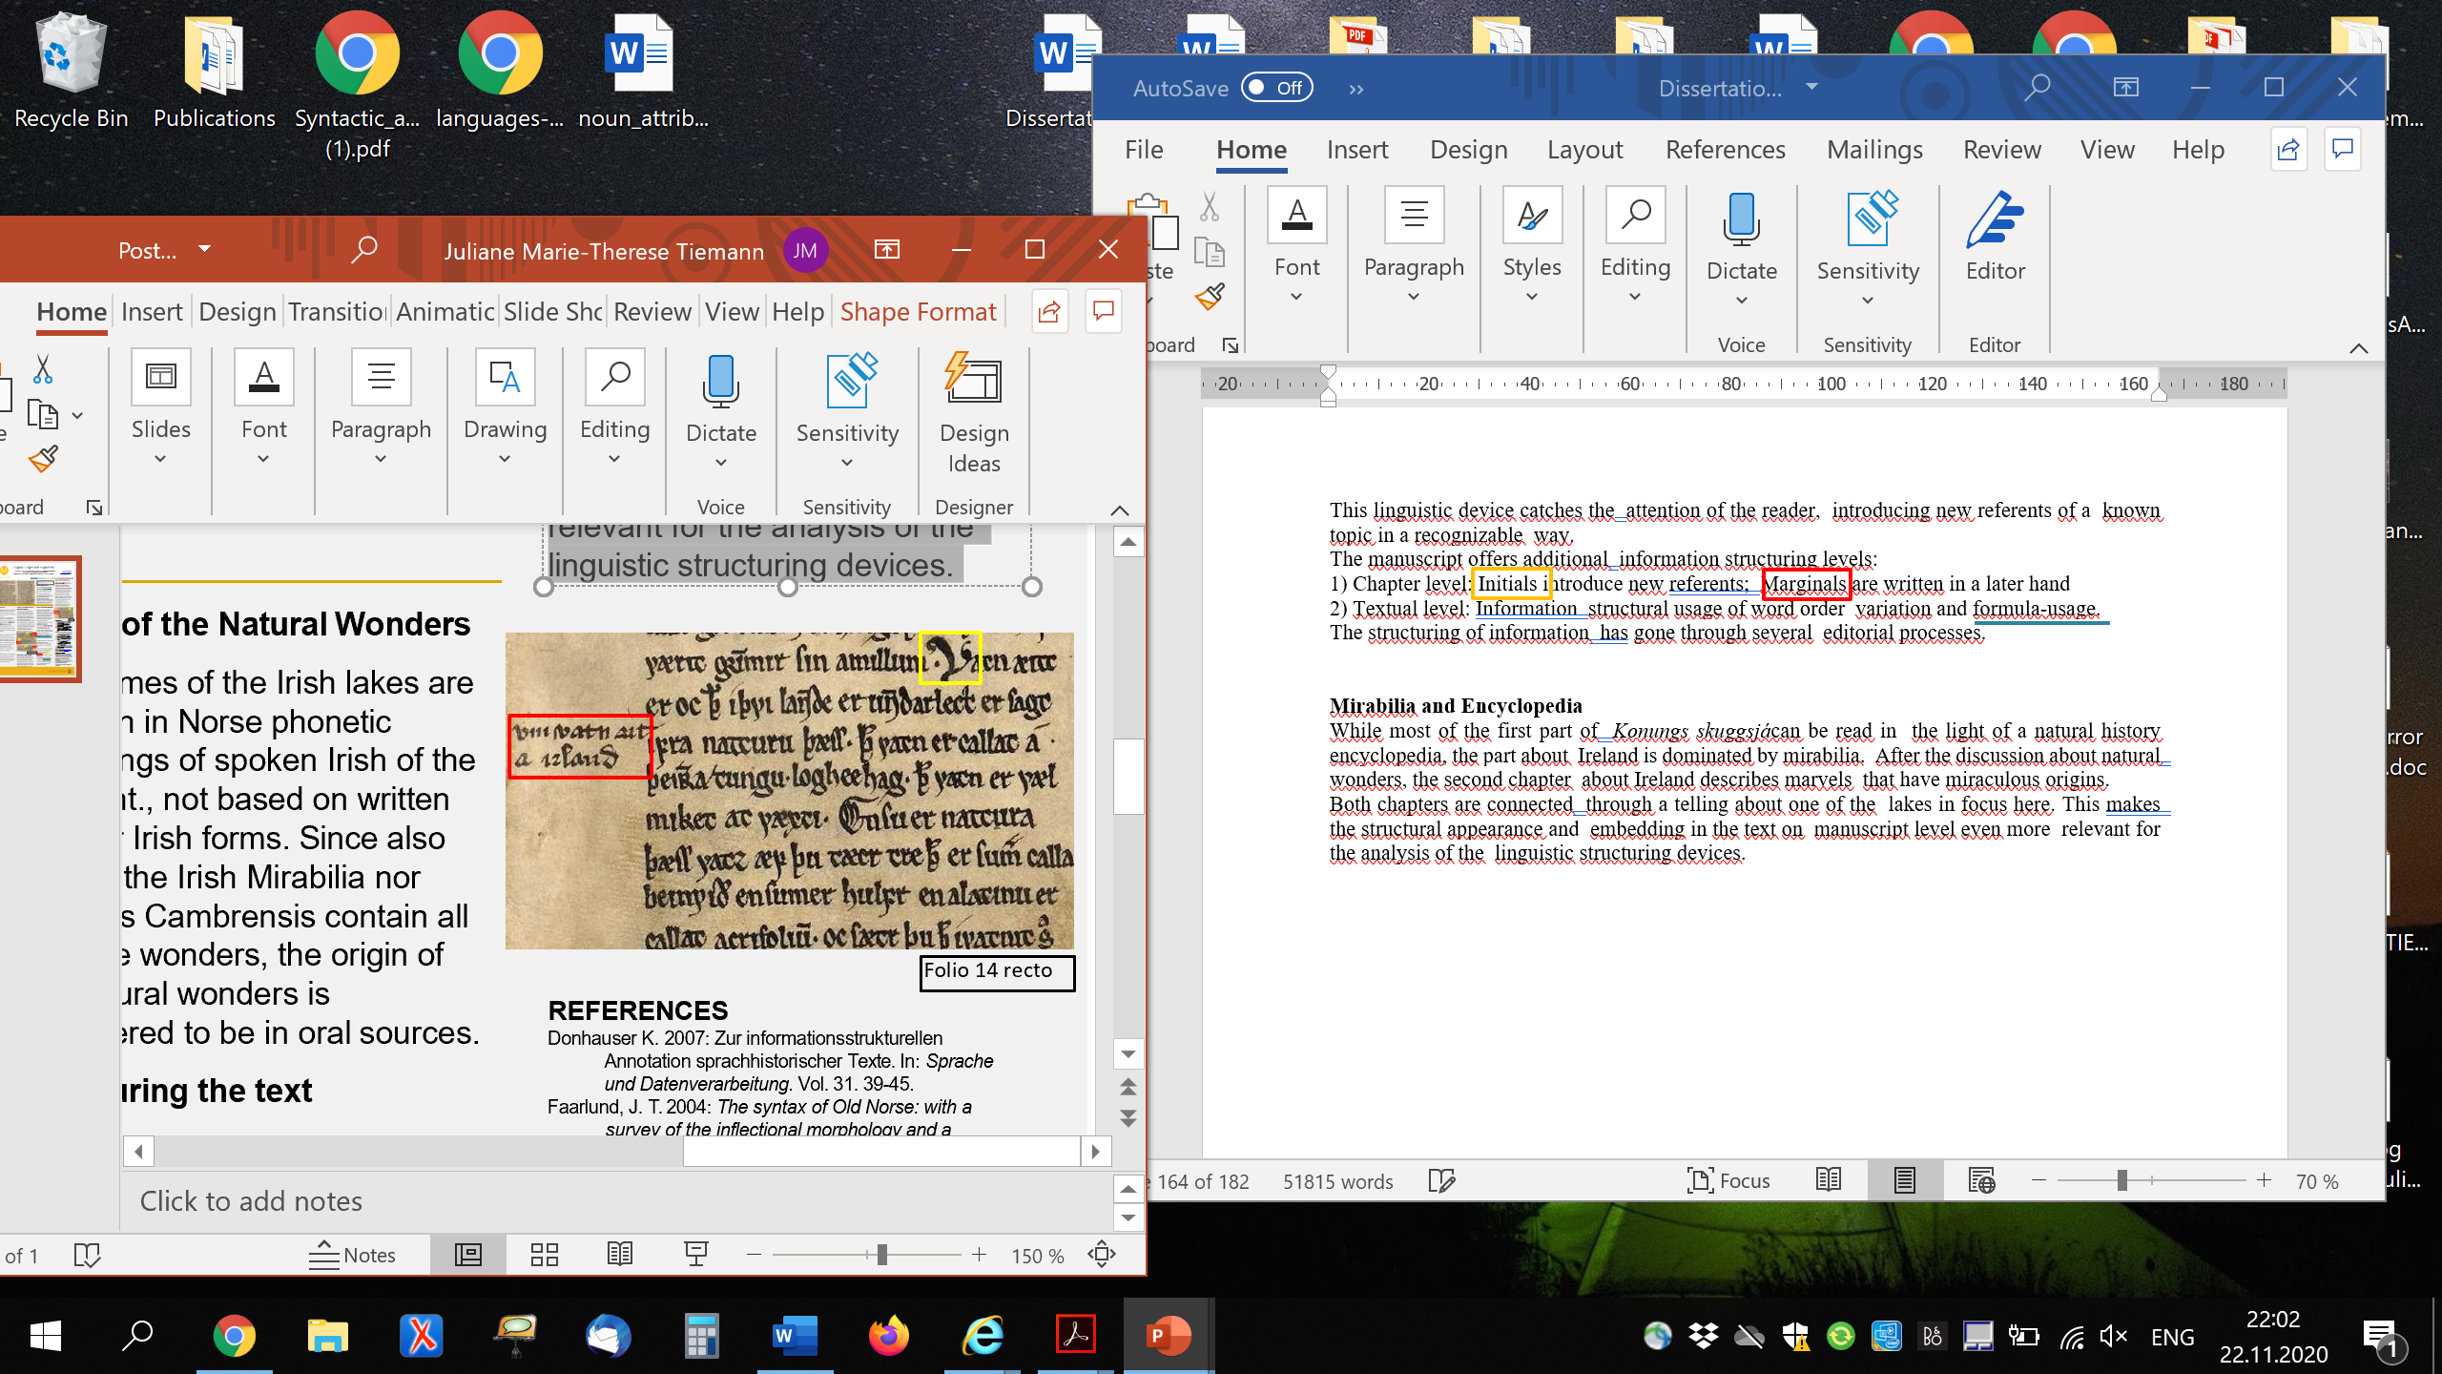

Fig. 4a: fol. 14r, Introduction of the overall topic.

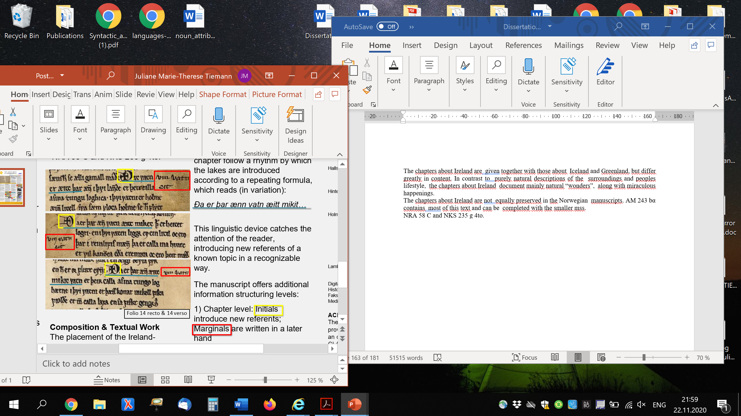

Fig. 4b: 14r, Reference to the first lake.



Fig. 4c: 14v, Reference to the second lake.



Fig. 4d: 14v, Reference to the third lake.

The combination of these guiding devices eases the reader’s navigation through the manuscript text. A reader thus can manoeuvre through the text by the means of several visual and textual markers – traces of editorial processes that have shaped this manuscript.

Bibliography
Copenhagen Arnmagnæan Manuscript Collection, AM 243bα fol. (Creative Commons License, handrit.is). https://handrit.is/en/manuscript/imaging/da/AM02-0243-b-alpha#page/Acc+Mat+1v+(2+of+145)/mode/2up (March 2021).
Cardelle de Hartmann, C. (2007): Lateinische Dialoge 1200 –1400. Literaturhistorische Studie und Repertorium. Leiden: Brill. [Mittellateinische Studien und Texte, 37].
Flom, George T. 1915. The Arnamagnean Manuscript 243 Bα, folio at Det Kongelige Bibliotek, Copenhagen. The main manuscript of Konungs skuggsjá in phototypic reproduction with diplomatic text. Urbana: The University of Illinois.
Holm-Olsen, Ludvig. 1952. Hándskriftene av Konungs skuggsjá: en undersøkelse av deres tekstkritiske verdi. (Bibliotheca Arnamagnseana 13).
-- 1983. Konungs skuggsiá. 2. rev. ed. Norsk historisk kjeldeskrift-institutt: Oslo. [Norrøne tekster nr. 1]. (1st ed. 1945)
Johansson, K. & E. Kleivane. (2018): ‘Konungs skuggsjá’ and the Interplay between Universal and Particular. In: Johansson, K. & E. Kleivane (eds.), Speculum septentrionale. Konungs skuggsjá and the European Encyclopedia of the Middle Ages, 9-34. Oslo: Novus Forlag.
Schnall, Jens Eike & Rudolf Simek (2000): Speculum regale. Der altnorwegische Königsspiegel (Konungs skuggsjá) in der europäischen Tradition. Wien: Fassbaender. [Studia Medievalia Septentrionalia 5].
Tiemann, Juliane. 2023. Syntactic variation and information structure in Old Norwegian : an investigation of Konungs skuggsjá in AM 243 bα fol. Doctoral thesis. University of Bergen.

Author information: Juliane Tiemann holds a doctor’s degree in Old Norse philology and is a senior academic librarian at the University of Bergen library.

